Drowsiness Detection and Alcohol Intoxication for Car Assisted Driver System Using Raspberry Pi

Pandurang N. Kathar*, D. L. Bhuyar, A. M. Rawate
Department of E&TC, CSMSS College of Engineering, Aurangabad (MS), India

Abstract
Drowsiness and drunken driving are noticeable causes for road accidents. In this paper we propose real time detection for driver’s drowsiness as well as alcohol intoxication and subsequent alerting system. The primary aim of this proposed system is to bring reduction in the number of road accidents caused due to driver’s drowsiness and alcohol intake, to facilitate an increase in the transportation safety. Our proposed system contains 8-megapixels digital USB camera, Raspberry-pi loaded with Raspbian-OS. Alcohol sensor (MQ-3) is used to detect the intake of alcohol in percentage, if the intoxication matching fails, alarm gets triggered on and GSM transmits a warming message. The Raspberry-pi system board is serially interfaced with Arduino Uno. GSM, Bluetooth, relay circuitry and buzzers are interfaced with Arduino Uno to alert driver through alarm notification and switching off the car power source.

Keywords: Drowsiness detection, Alcohol intoxication, Raspberry pi, Arduino UNO, OpenCv, GSM

*Author for Correspondence E-mail: banti1697@gmail.com

INTRODUCTION
Most of the road accidents are caused because of drowsiness and drunk driving, rough working environments, reduced sleep and long working hours. Driver drowsiness and fatigue drunk driving reduces the driver decision making capability and decreases perception level. Both the situations affect the ability to control the vehicle and alert decision making. There are few techniques which are used to detect drowsiness in drivers like sensing driver operation or physiological characteristics of driver or by vehicle movement etc. Traffic survey’s show that driver fatigue may be a contributory factor in up to more than 20% and due to alcohol drinking it is about 31% of all road accidents [1].

The primary purpose of our drowsiness and alcohol detection system is to develop a system that can reduce the number of accidents from drowsiness and drunk driving of vehicle [2]. The first part of the this project is detecting drowsiness, for that we use a camera for detecting image or face, eye detection is the important part of this project which is done using OpenCV [3,4]. The Input 8-megapixel camera is capable of capturing real time images and video. The captured video frame is processed on Raspberry pi. Drowsiness detection algorithm is implemented using Python [5,6]. Eye close detection is based on Haar cascade classifier and canny edge detection technique and performs several comparisons from a database of positive value and negative value of images and returns a red border rectangle over the detected area on matching [7,8]. Eye closing rate is calculated after each 8 sec, after crossing a predefined threshold value, the Raspberry pi sends a high pulse signal serially to its slave device Arduino Uno. On receiving the high pulse signal, the Arduino performs a set of tasks like alarm by buzzer or send message to its car owner [9,10]. On the other hand alcohol sensor (MQ-3) works as a breathalyzer and calculate blood alcohol content (BAC) from breath alcohol content (BrAC). The Arduino is interface with MQ-3, Bluetooth, buzzer and relay. Arduino continuously checks alcohol content present in the air and also computes blood alcohol content in percentage from it. [11]. If the calculated % BAC crosses the threshold limit, it will instantaneously give alarm through buzzer and will turn off the relay and hence the moving vehicle. If drunk limit crosses over then a message is sent through GSM to the car owner.

MATERIALS AND METHODS
System Hardware and Configuration
Software Configuration
In our proposed system there are some necessary software tools required for the system includes Raspbian operating system, Python IDLE and Compiler, OpenCV, Computer vision library extension for python with Haar cascade classifier and object detection, Canny edge detector, Arduino IDE and programmer for alcohol sensors and corresponding outputs and AT commands are used for GSM modem for messaging purpose.

Hardware Modules
i) Raspberry Pi Board
Raspberry Pi (represented in Figure 1) is a credit card sized single-board computer. Generation 2 Model B also has four USB ports, one GB RAM, USB camera interface and 1HDMI interface and 40 GPIO allows us to control and interact with real world.

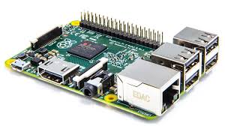
Fig. 1: Raspberry pi2 Model B.

We implemented system using Raspberry pi2 Model B. It has a Broadcom BCM2836 system on chip which includes an ARM1176JZF-S 1000 MHz processor, Video Core IV GPU, and an SD card. The GPU is capable of Blu-ray quality playback, using H.264 at 40MBits/s. It has a fast 3D core accessed using the supplied Open GL ES2.0 and Open VG libraries. The chip specifically provides HDMI and there is no VGA support. The foundation provides Debian and Arch Linux ARM distributions and also Python as the main programming language, with the support for BBC BASIC, C and Perl.

ii) Arduino UNO development board
In Arduino Uno (represented in Figure 2),"Uno" means one in Italian and is named to mark the upcoming release of Arduino 1.0 version. The Arduino Uno is a microcontroller board based on the ATmega328. It has 14 digital input/output pins (of which six can be used as PWM outputs), six analog inputs, a 16 MHz crystal oscillator, a USB connection, a power jack, an ICSP header, and a reset button. It contains everything needed to support the microcontroller; simply connect it to a computer with a USB cable or power it with an AC-to-DC adapter or battery to get started. The Uno differs from all preceding boards in that it does not use the FTDI USB-to-serial driver chip. Instead, it features the Atmega8U2 programmed as a USB-to-serial converter.

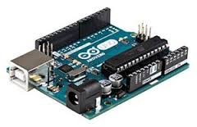
Fig. 2: Arduino UNO Development Board.

iii) Camera Interface
The USB camera module (shown in the Figure 3) used in this project. The camera plugs directly into the USB connector on the Raspberry Pi. It's able to deliver clear 8MP resolution image, or 1080p HD video recording at 30fps. This USB camera which has no infrared filter making it perfect for taking infrared photographs or photographing objects in low light (twilight) conditions.

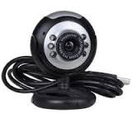
Fig. 3: USB Camera.

iv) GSM Modem (SIM900)
In this system GSM is used, operating frequency of GSM lies in between 900 MHz and 1.8 GHz bands. One of the most leading digital systems is GSM. GSM uses narrow band Time Division Multiple Access (TDMA). Of all time GSM becomes the world's fastest growing communications technology. It is the leading global mobile standard. GSM is an open, digital cellular technology, which is used for transmitting both data services and mobile voice. The GSM is able to support data transfer speeds of up to 9.6 kbps. It also allows the transmission of basic data services such as SMS (Figure 4).

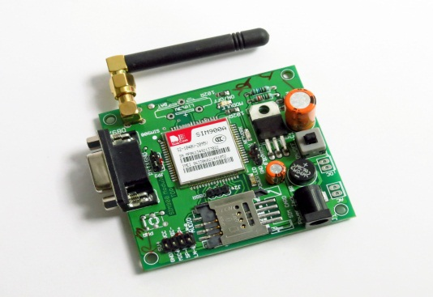
Fig. 4: GSM Modem (SIM900).

v) Alcohol Sensor (MQ-3)
The alcohol sensor will detect the alcohol; depends on human breath, i.e., if the driver has consumed alcohol, it will be identified by his breath, and the sensor will display on the LCD regularly. The sensor is placed in front of the driver.

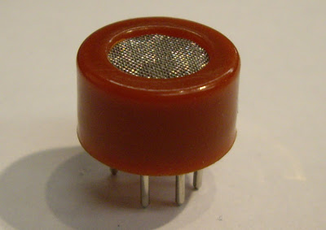
Fig. 5: MQ-3 Alcohol Gas Sensor.

The alcohol sensor MQ-3 is selected in this system due to its high sensitivity in detection and has good resistance to disturb of gasoline, smoke and vapor (Figure 5). The sensor is able to detect BAC with different concentration and classified the range of BAC detected into a few level. The alcohol sensor MQ-3 is a heater-driven alcohol gas sensor, its output is an analog signal which measures alcohol content. It is used to measure the present of alcohol in the volume of breath in mg/L (milligrams per liter). These are also known as Breathalyzer or breathe content (BrAC). We can determine the driver consumed alcohol or not by the percent of BAC in blood of driver.

MQ BrAC values can be converted to
BAC.0.1% BAC = 1000 mg/L

METHODOLOGY
In this section results are obtained using software and hardware platforms to achieving the objective of driver drowsiness detection and alcoholic intoxication. Besides eye and head movements, another visual cue that can potentially capture one’s level of drowsiness is his/her eyes and faces detection analysis. Making a real time application with computer vision is very effective and efficient challenging task that needs processing powerful system. OpenCV is open source software, which is library used for working with Computer Vision. OpenCV is available as wrapper for C, C++, and Python and Java programming languages extension. Raspberry pi is Credit card sized ARM controller with GPU that provides up to 1.5 Gpixels of graphics processing and a CPU, processing at 1000MHz. It can be over clocked at a maximum of 1500MHz. Raspberry-pi can work with Raspbian operating system, which is a light weight Linux. Raspbian OS loaded with programming software and OpenCV. It supports interfacing of various low level and high level peripherals including USB camera and GPIO’s. In case of driver is in sleepy state or finding fatigue, the message will be sent by using GSM and buzzer will be turned on till the GSM positive message from car owner. Figure 6 shows the basic block diagram of the proposed system. Haar Feature based Cascade Classifier technique, it is a machine learning based approach where a cascade function is trained from a lot of positive and negative images, and this positive image is used for detecting face region and eye region the update of region of interest ROI. OpenCV is packed with a trainer as well as detector. The OpenCV is used for creating user defined object classifier. The object classifier that has been created is stored in .xml file extension classifier can be used in the later stages of programming. Also in this paper we use canny operator edge detection to recognize exact coordinate of eyes region. On the other hand of the system Arduino is used for detection of the alcohol consumption by the person, alcohol gas sensor or Breathalyzer MQ-3 is interfaced. Arduino will detect samples of the person who is driving drunk or not. Based on the output from Arduino, an alarm will be turned on and the car’s ignition power source can be cut down through a relay to stop the car or preventing the driver to start the car. If driver is over drunk then the message will be sent by using GSM and buzzer will be turned on till the GSM positive message from car owner.

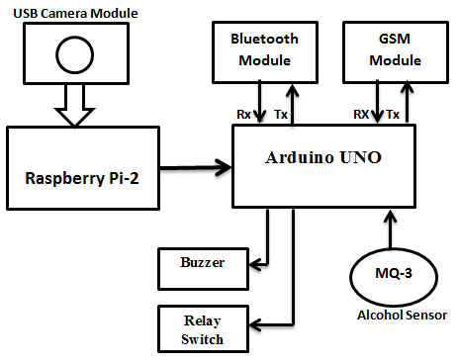
Fig. 6: Block Diagram of the Proposed System.

Proposed Algorithm (Figure 7)
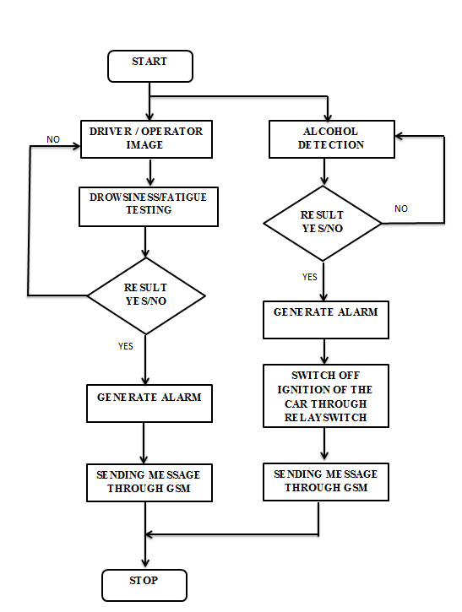
Fig. 7: Logic Flow for the System.

Flow Chart Description
- Driver seats on the driver seat.
- Initially driver’s image will be taken via camera.
- Corresponding to this an alcohol intoxication test is also done initially before the car is started.
- The program will start monitoring the driver’s eyes with respective alcohol detection.
- If the eye’s pupil is not read by the camera or unless eyes are found to be closed for more than the time set in programming timer then an alarm notification will be given through buzzer.
- So upon detection of the fatigue an alarm can be generated and alertness can be provided to the sleepy driver.
- In second scenario, If driver number of closed eyes frame’s is crossed peak level at that time one message is send through GSM to that car owner.
- On the other hand alcohol intake will be detected in percentage through alcohol sensor and if the result is positive (up to 60% of alcohol) then an alarm will be generated and if alcohol level is crossed (above 80% of alcohol) then car’s power/ignition source will be cut down through relay switch, at that time message is send through GSM to the car owner.
- Hence if the driver is drunk then he would not be able to start the car in initial state only and this system will help in preventing driver to drive in inappropriate state.
- Hence with the help of this system alertness can be provided to a drowsy driver through alarm and drunk driving can also be prevented simultaneously.

RESULTS
This proposed system is still in research level. We have used USB camera connected to Raspberry pi which is loaded with Raspbian O.S and Python with OpenCV. The detection algorithm can detect image of driver through camera, face region is marked with green rectangle, and the region of interest that shows the eye region is marked with red color rectangle (Figure 8).
In Figure 9, eyes of the person are closed; hence eyes closed are detected with a red rectangular frame by the system. If the closed eyes frame is detected for more than five frames in a program, an instantaneous warning alarm through buzzer is generated. In other condition if closed eyes frames are more than threshold value of 10 frames, the system transmit a pin high of the Raspberry Pi GPIO’s which is serially interface with Arduino UNO and a message is sent through GSM Modem.

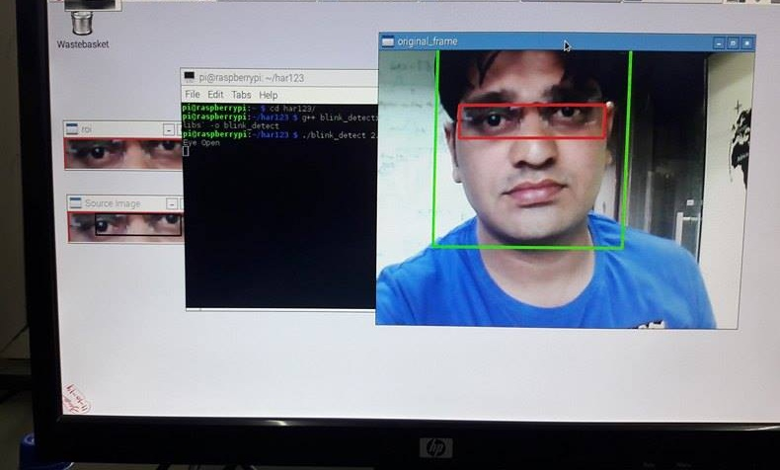
Fig. 8: Detection of Face, Open Eye Detection.
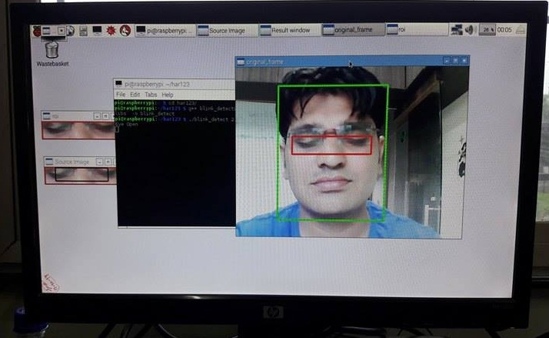
Fig. 9: Detection of Face, Closed Eyes Detection.

The Prototype runs on raspberry pi and Raspbian Operating System. The input is fetched from the USB camera, the video feed is passed to process through Opencv and Python and Face and Eye Detection Algorithm. The system can be made more powerful and fast by using processing boards that possess higher processing capacities

In order to detect the Alcoholic Intoxication of the driver, an alcohol gas sensor (MQ3) works as a Breathalyzer to calculate alcohol intake of the driver. The testing and observation of MQ-3 alcohol sensor is based on the Arduino UNO programming. At the time of testing of MQ-3 alcohol sensor there are different voltages level/samples at output. The sensor continuous variation is in the range of 0 to 1023, because there is 10 bit ADC output. In this system, the alcoholic intoxication is displayed in the percentage, for that purpose we program as per our condition that voltage samples is converted into percentage using Mapping Diagram Concept. If the input of alcohol is 0 to 60% at the time, output is in the form of a buzzer indication to the driver. If the input of alcohol is above 70% at the current time, GSM modem gets activated through Arduino UNO and a message is sent to the car owner as well as the ignition of the car is switched off through relay switch to prevent drunk driving.

The system begins to operate when the alcohol sensor detected BAC level from the driver. Then it will send the signal to Arduino UNO for further process which will involve the LCD display, alarm and ignition system. BAC level detected by alcohol sensor is based on gas or alcohol concentration in ppm (parts per million). This system is tested by whisky alcoholic drinks/after shave lotion as the input to the experiment. The alcohol sensor can sense an alcohol from human breath from 0 ppm until 1000 ppm. The result is categorized into four conditions of the driver with different value (in percentage) of BAC level which are intoxication, slightly drunk, drunkenness and over limit drunk.

Table 1 shows the achieved result. Table 1: Result achieved in different level of drunkenness in ppm for first condition, LCD will display “intoxication” when the alcohol sensor detected BAC level from 0 to 20%. This condition showed that the driver is free from alcohol and there is no alarm sound from the buzzer is activated. While the ignition system is enable means the driver is conscious and can drive the vehicle on the road safely. The next condition is slightly drunk with 21 to 40% drunkenness level. This means the driver has drunk with a little amount of alcohol, but needs to be assisted during the driving on the road. The buzzer is activated to alert the driver and the people in vicinity that the driver is slightly drunk. The third condition drunkenness level with 41 to 60%. This means the driver has drunk with a little strong amount of alcohol, but needs to be assisted during the driving on the road. The buzzer is activated to alert the driver and the people in vicinity that the driver is slightly drunk. In the last condition, the ignition system is deactivated as the level of BAC is too high. The driver is totally unconscious and not safe for driving. Figure 6 show the corresponding value of BAC in ppm to the alcohol sensor output voltage. Ultimately, this system helps to prevent the driver from driving in risky situation and will thus, avoid accident on the road

Table 1: Result Achieved in Different Level of Drunkenness in ppm.
Output | Level of Drunkenness
Output | 0–20% | 21–40% | 41–60% | 61–99%
LCD Display | “Intoxication” | “Slightly Drunk” | “Drunkenness” | “Over limit drunk”
Buzzer Indication | OFF | OFF | ON | ON
Ignition System | Enable | Enable | Enable | Disable
Message Send by GSM | NO | No | NO | YES

For a better understanding of MQ-3 alcohol intoxication, six types of samples consider what happens when you pour some whisky into a glass and then smell the air above it, there is a strong smell of alcohol with peak level voltage of MQ-3 sensor. If you now add some water to the whisky then the concentration of alcohol in it decreases, and so therefore, small amount of smell of alcohol in the air with respective voltages. So measuring the strength of alcohol in the air above a drink enables us to determine what concentration of alcohol is actually present in the drink.

So the level of alcohol in the breath depends on its concentration in the blood shown in Table 2.

Table 2: Output Voltages for the MQ-3 Alcohol Sensor Circuit.
No. of Samples | Operating Voltage of MQ-3 Sensor | Alcohol Sensor Mq-3 Output Samples in PPM
No. of Samples | Operating Voltage of MQ-3 Sensor | 0–10% | 11–20% | 21–30% | 31–40% | 56–60% | Above 60%
No. of Samples | Operating Voltage of MQ-3 Sensor | Red Line | Sky Blue | Green | Yellow | Blue | Black
1 | 0 v | 0 | 0 | 0 | 0 | 0 | 0
2 | 0.5 v | 0 | 22 | 82 | 76 | 163 | 213
3 | 1 v | 30 | 30 | 98 | 102 | 332 | 312
4 | 1.5 v | 35 | 98 | 193 | 196 | 556 | 619
5 | 2 v | 52 | 115 | 223 | 234 | 623 | 782
6 | 2.5 v | 66 | 135 | 283 | 294 | 762 | 886
7 | 3 v | 79 | 142 | 297 | 315 | 782 | 889
8 | 3.5 v | 91 | 147 | 297 | 317 | 784 | 889
9 | 4 v | 93 | 148 | 297 | 317 | 785 | 889
10 | 4.5 v | 98 | 150 | 297 | 319 | 790 | 893
11 | 5 v | 98 | 155 | 299 | 319 | 792 | 894

Graph 1 shows different types of output voltages for alcohol detection in ppm with the help of above readings for different alcohol content samples, here the response of different samples is parts per million (PPM) versus alcohol sensor operating voltages in volt is shown in Graph 1.

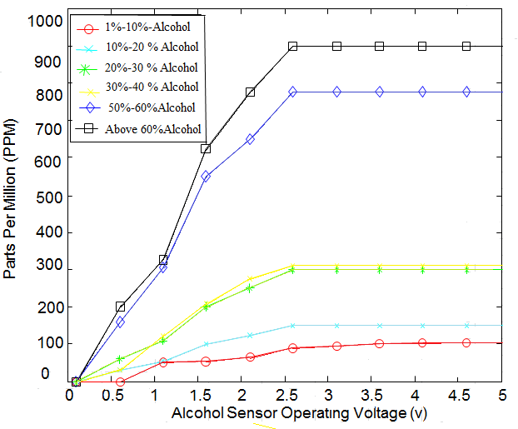
Graph 1: Response of ppm (In Percentage) via Alcohol Sensor Output Voltages Values.

CONCLUSIONS
In our research, we have presented the application of computer vision with embedded systems targeted for reducing road accidents due to driver drowsiness and alcoholic intoxication. We are monitoring and detecting the driver’s behavior to ensure road safety and avoid road accidents. It is important to capture driver behavior which will reduce the accidents due to rash driving under the influence of alcohol.

The proposed system deals with detection of alcohol and drowsiness using sensors to get the notification message with help of GSM modules and accordingly precautions are taken. The system works well even in case of drivers wearing spectacles and under low light conditions also. The Algorithm we implemented works exceptionally well in all the circumstances. We have discovered that upgrading hardware gives better results.

ACKNOWLEDGMENTS
Acknowledgments recognize the contribution of funding bodies and anyone who has assisted in the work.
REFERENCES
- Dwipjoy Sarkar, Atanu Chowdhury, A Real Time Embedded System Application for Driver Drowsiness and Alcoholic Intoxication Detection, Int J Eng Trend Technol (IJETT). 2014; 10(9): 461–465p.
- Prasanthi TD, Rajasekhar K, Janardhana Rao TV, et al. Design of ARM based face Recognition system using Open CV library, Int J Adv Res Comp Technol (IJARCET). 2012; 01(9): 233–240p.
- Varsha E dahiphale, Sathyanarayana R. Computer Vision System for Driver Fatigue Detection, Int J Adv Res Electr Commun Eng (IJARECE). 2015; 04(9): 2331–2334p.
- Saeid Fazli, Parisa Esfehani, Tracking Eye State for Fatigue Detection, International Conference on advanced in Computer and Electrical Engineering (ICACEE’2012), 2012, 17–18p.
- Lorraine Saju, Christeena Jestine, Farhana Yasmin, et al. Drowsiness Detection System for Drivers using Haartraining and Template Matching, Int J Eng Appl Sci Technol. April - May 2016; 1(6): 106–110p.
- Dhaval Pimplaskar, Nagmode MS, Atul Borkar, Real Time Eye Blinking Detection and Tracking Using OpenCV, Int J Eng Res Appl. 2013; 03(05): 1780–1787p.
- Naveen M, Sudarvizhi S. Finger Vein Recognition Based Driver Authentication and Alertness System Using GSM, Int J Res Eng Adv Technol (IJREAT). 2015; 3(1): 211–216p.
- Srinivasu Batchu, Praveen Kumar S. Driver Drowsiness Detection to Reduce the Major Road Accidents in Automotive Vehicles, Int Res J Eng Technol (IRJET). 2015; 02(01): 345–349p.
- Nikitha L, Kiranmai J, Vidhyalakshmi B. Driver Behaviour Analysis Using Non-Invasive sensors, Int J Adv Eng Sci (IJATES). 2015; 03(01): 707–714p.
- Saurabh Thakur, Shekhar Dure, Ajinkya Khutwad, Advance Vehicle Control and Safety System Using Face Detection, Int J Adv Res Sci Eng (IJARSE). 2015; 4(5): 141–146p.
- Ashutosh U. Jadhav, Wagdarikar NM. Intelligent Vehicle System for Driver Assistance, Int J Adv Res Elect Electr Instru Eng (IJAREEIE). 2015; 4(7): 6616–6623p.

Cite this Article
Pandurang N. Kathar, Bhuyar DL, Rawate AM. Drowsiness Detection and Alcohol Intoxication for Car Assisted Driver System Using Raspberry Pi, Recent Trends in Sensor Research and Technology. 2016; 3(2):

